Tutorial 1: Introduction to Python

This tutorial is designed to introduce you to Python for basic data analysis. You will learn how to work with log files, import essential libraries, and load an Excel dataset into Python. The tutorial covers browsing and summarizing data, computing descriptive statistics, creating new variables, and generating visualizations such as histograms and scatterplots. Additionally, you will learn how to calculate correlation coefficients, variance, and covariance using Python, and how to save outputs—including figures and logs—for documentation.

Task

The data for this question is in file called income (available in “Tutorial 1 assignment” folder). This is a sample of 142 individuals living in households in the UK Midlands in 2018.

Variable Name | Description
Age | Age in years
Sex | Sex
eth | Ethnic origin (self-reported)
Inc | Household income in pounds per year
edu | Age at which left full time education

- Open a log file to keep a record of your analysis of the data.

- Browse the dataset and summarise the mean, standard deviation, minimum and maximum for all the numerical variables.
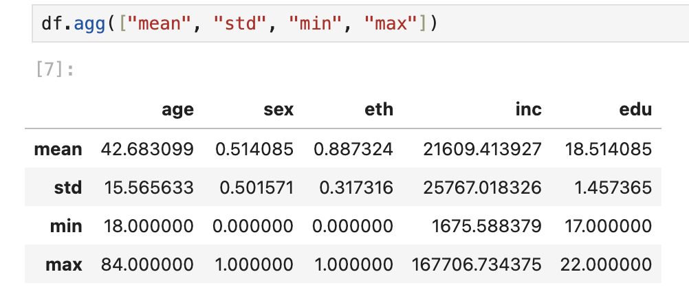

- Draw a histogram for income (inc). Construct a new variable equal to the logarithm of income, draw a histogram of this variable and comment. Draw separate histograms by ethnic origin (eth) and comment on any difference visible.

Histogram for Income
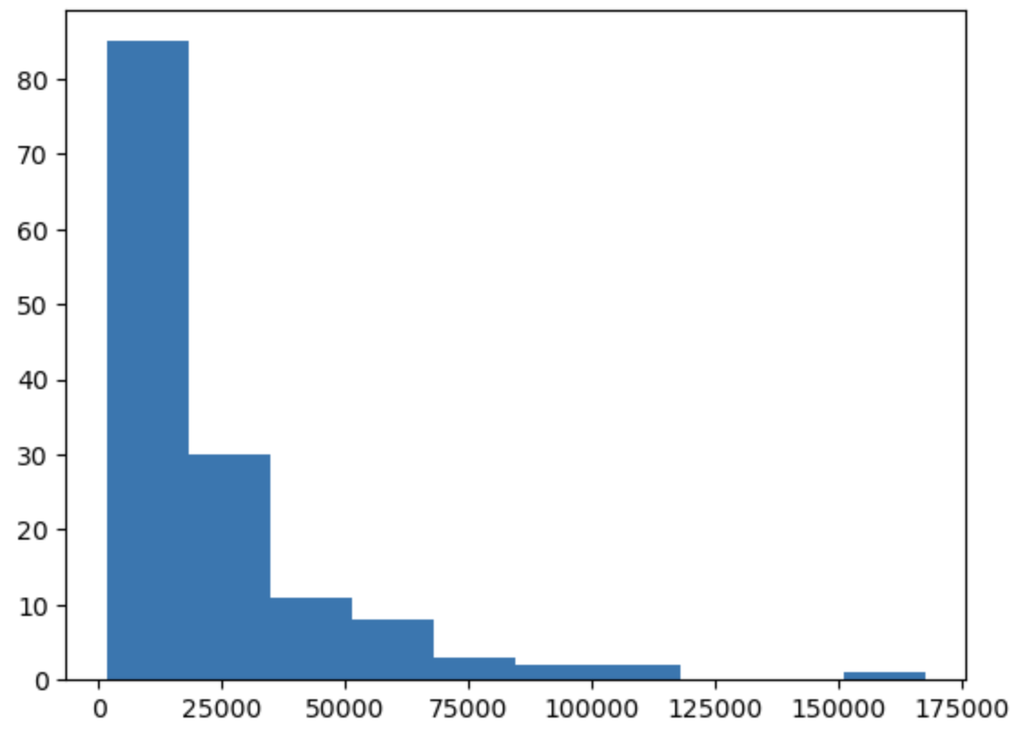
Histogram for Log Income
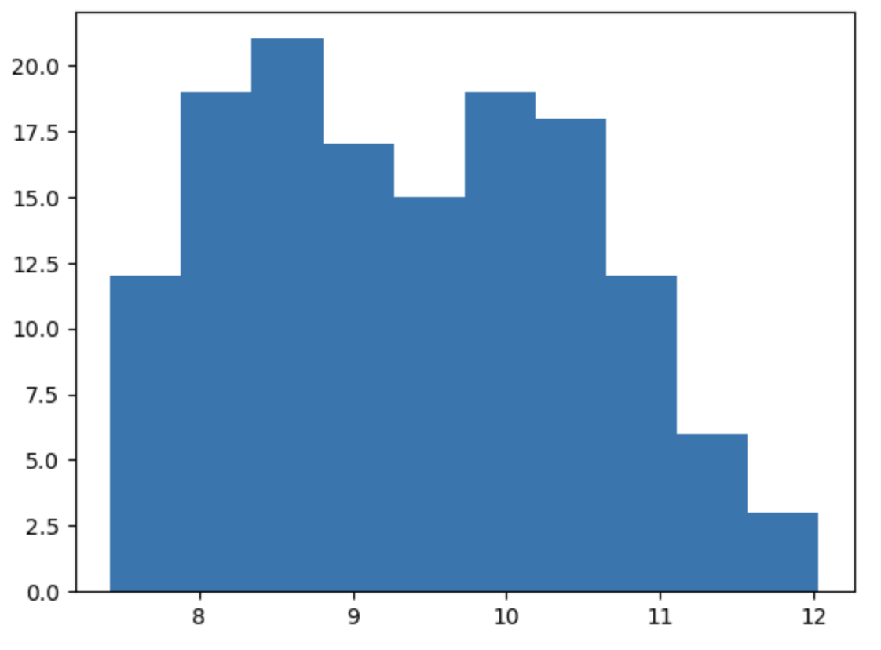
Histogram for Ethnic Origin
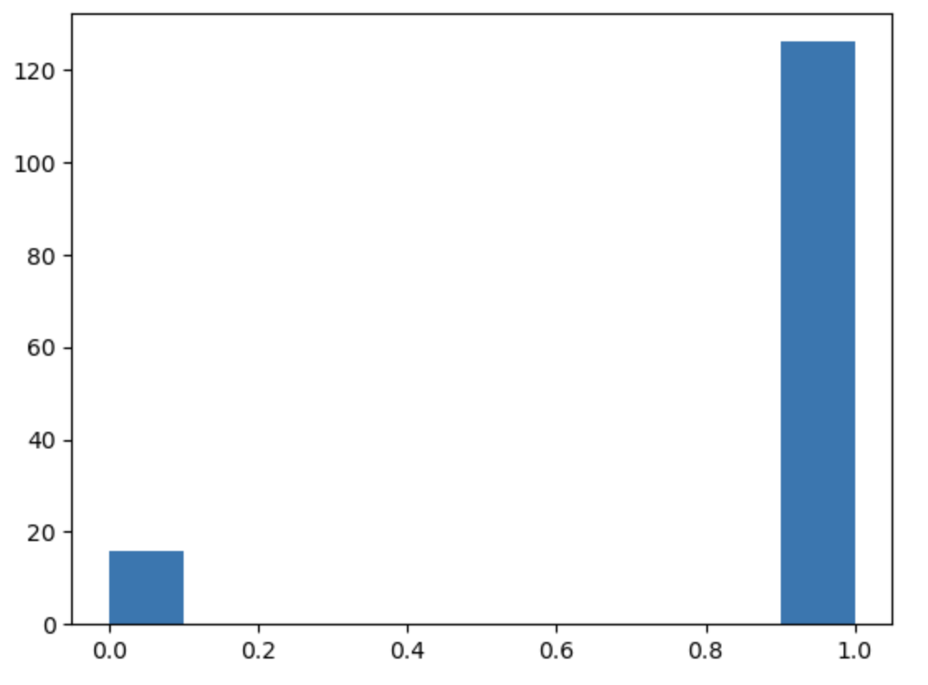
- Draw a scatterplot of income (Inc) against education (edu). Calculate the variances of education and income, as well as the correlation and covariance between them. What does the correlation coefficient suggest about the relationship between education and income? Finally, discuss whether you can conclude that higher education causes higher income?

